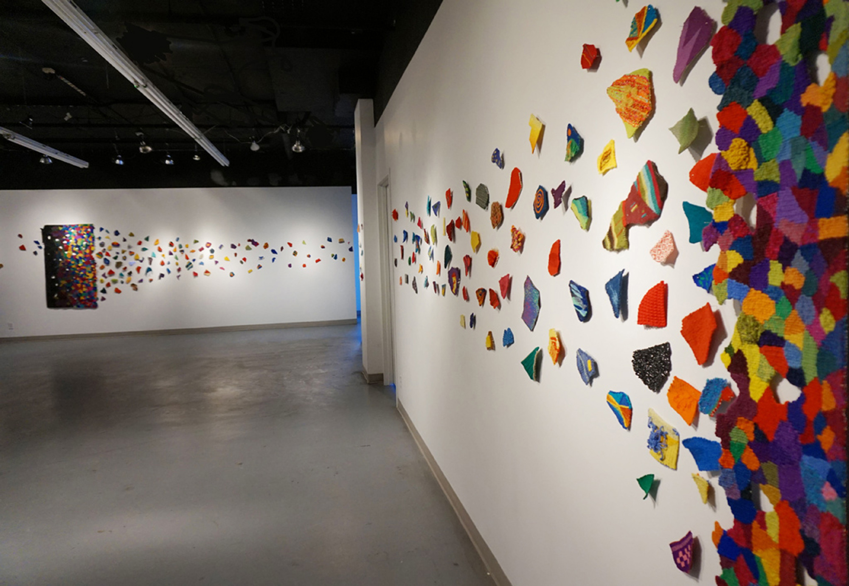
Le Sort, Destin, et l’auto-determination / Fate, Destiny and Self Determination is an international tapestry initiative . Weavers and non weavers from all over the world are invited to participate. To date 230 people are from 22 countries have contributed a total of 372 shapes. It continues to grow by accepting shapes on an ongoing basis indefinitely.

The installation is composed of three sections. Section one is composed of shapes, not greater than 10cm (4”). Anyone who wishes to do so, can create a shape using textile related technique ( tapestry, rug, weaving, felt, etc) with whatever non perishable material or fibre they like. I’m suggesting you choose any hue (not a tint or shade) from the colour wheel) if possible. You can use more than one colour.

Line Dufour, the artist who launched the project, wove the second section, the main panel at the back wall. Section three (the panel in the foreground) was woven on the Gobelin loom at the Toronto Weaving School in Toronto by the general public. The installation has been exhibited in Toronto (Craft Ontario), Montreal(Montreal Centre for Contemporary Textiles), Regis University in Denver, Colorado; the Craft Council of British Columbia (March 2016); China (from Beijing to Lausanne) and will be going to the San Jose Museum of Quilts and Textiles as part of the American Tapestry Alliance Biennial 11. In August 2016, it will go to the Centre D’Action Culturelle de la MLC de Papineau, Quebec, followed by the World Textile Art Biennial in Uruguay, and another exhibition at Art Gallery of Burlington at the end of 2017. Other possible exhibitions are being negotiated, planned and discussed: Australia, Poland, France, UK, Ireland and Italy. The installation is open to receiving invitations to exhibit in your area.

All participants are named at each exhibition. A video and slide show of the project is part of the exhibition with the final tapestry installation. When your shape(s) arrives, it is posted on the Facebook page for the project, along with your name and website and any information or thoughts you would like to share with others. If you have any questions don’t hesitate to contact me at linedufour.tapestry@gmail.com.

If you want Line Dufour to send you a shape contact her at the email address below. If I have attached a shape with your email, it may have to be reduced so that no side is greater than 4” or 10cm. A person can also weave (create) a shape of their country, state or province or any shape except a circle, square or rectangle. You can look at the Facebook page for the project to see how other people have created their shapes. www.facebook.com/pages/Fate-Destiny-and-Self-Determination-An-international-tapestry-project/
Please invite other weavers, fibre artists to participate and feel free to send them this information sheet. They can email me to receive a shape (s) or they can create their own.

The installation is also accepting donations to pay for the high costs of touring it all over the world. Go to www.tapestryline.com and click on the GoFundMe link to make a donation.

Return the completed shapes at your expense to: Line Dufour, 25 Beckett Ave, Holland Landing On L9N 1E6, CANADA

Thank you for participating and making this an exciting project! Line Dufour

